The City of Red Cloud, Nebraska

Community Welcome Packet

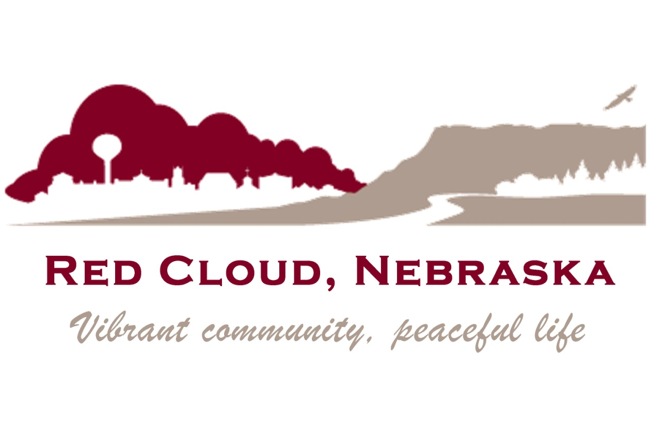

Red Cloud Area Chamber of Commerce
P.O. Box 327
Red Cloud, Nebraska 68970
Telephone: (402) 746-3238
Email: redcloudchamber@hotmail.com
Website: http://www.redcloudnebraska.com
#weareRC

TABLE OF CONTENTS

Welcome to Red Cloud! ...................................................................... 3
A Quick Start Guide to Living In Red Cloud .................................... 4
City of Red Cloud Municipal Information ....................................... 4
City Officials .............................................................................. 4
City Departments....................................................................... 5
Helpful Phone Numbers …………………................................................ 5
Community Numbers ………………………………………………............. 5
Webster County …………………………………………………………....... 5
Heritage tourism………………………………………………………………. 6
Schools ……………………………………………………………………………. 6
State of Nebraska …………………………………………………………… 6
U.S. Government ………………………………………………………………. 6
Medical …………………………………………………………………………….. 6
Emergency Numbers ………………………………………………………… 6

Welcome To Red Cloud!
The Red Cloud Area Chamber of Commerce and all of our friendly residents want to welcome you to our community! We have put together this COMMUNITY WELCOME PACKET to provide you with information about our community that can get you familiar a lot faster than having to find everything out by yourself. In addition, we hope that the information provided in this packet will encourage you to take the opportunity to patronize our local merchants, businesses, and organizations. Please get to know them and learn what kinds of goods, services, and activities are available right here in Red Cloud. If you can’t find what you’re looking for, be sure to ask. Shop Red Cloud first!
* * * * * * * * * *
Red Cloud, named for the Ogallala Sioux Chief, was founded early in 1871 on homestead land filed upon by Silas Garber and company. When Webster County was later organized, Red Cloud was voted the county seat. The election was held in the dugout of Silas Garber, Nebraska's governor, 1875-79. The mainline of the Burlington and Missouri River Railway reached the town in 1879, accelerating immigration from the East and abroad, bringing together a colorful variety of cultural heritages.
During the 1880's Red Cloud served as a division center for the railroad. The architectural design of downtown was established during the prosperous time when many of the first frame and log structures were replaced by more elaborate two-story buildings of brick and stone. The historic brick streets remain in downtown Red Cloud as well as many of the original buildings, including the majestic and refurbished Opera House and the recently renovated Moon Block which is now the National Willa Cather Center and Archive.

Red Cloud is the hometown of Nebraska’s Pulitzer Prize winning author, Willa Cather. Here you can visit her childhood home, her beloved Opera House, and other historic buildings related to her life and writing. Located just east of Red Cloud, the Starke Round Barn is truly an architectural wonder. The massive structure measures 130 feet in diameter, and was built using a nail-free construction method. This eye-catching attraction is the largest in Nebraska and the largest “true” round barn in the world. The Webster County Museum is also housed in Red Cloud. The museum displays the rich heritage of early settlers of the plains of Webster County.
* * * * * * * * * *
So “WELCOME TO RED CLOUD!” We sincerely hope you will enjoy living here in the Heartland of America as much as we do. If you have internet access, be sure to visit Red Cloud’s website at www.redcloudnebraska.com for more information about our city. If you have any questions, need any additional information or help with anything at all, feel free to call, write, or email:

Red Cloud Area Chamber of Commerce
P.O. Box 327
Red Cloud, NE 68970
Email: redcloudchamber@hotmail.com
(402) 746-3238
A Quick Start Guide to Living in Red Cloud

Utility Information

Electric, Sewer, Water City of Red Cloud 402-746-2215

Electric (Rural Areas) South Central Public Power District 800-557-5254

Trash R&M Disposal 402-746-2302
Natural Gas Black Hills Energy 888-890-5554

Telephone Service Great Plains Communications 888-343-8014

Cable Television Eagle Communications 877-613-2453

Satellite Television Direct TV 800-217-9407
Dish Network 800-333-3474

Cellular Service U.S. Cellular 888-944-9400
Verizon 800-922-0204
Viaero 877-484-2376

Internet Great Plains Communications 888-343-8014
Glenwood 888-756-4638
Eagle Communications 877-613-2453

Municipal Information

City Officials

Mayor Gary Ratzlaff

City Council South Ward: Marianne Reynolds
North Ward: Gene Horne (President)
South Ward: Roy Phillips
North Ward: Brenda Knehans

City Attorney Kory McCracken

Note: The City of Red Cloud has a mayor-council form of government with all city officials elected to four year terms of office. City Council meetings are held at 7:00 pm on the 1st Tuesday of each month at the conference room of the Red Cloud Community Center. The public is welcome to attend.

City Departments

Administrative Sue Meline, City Clerk 402-746-2215

Maintenance Wes Olson, Superintendent 402-746-2214

For information about City Ordinances, forms and permits, incentive programs, job listings or how to pay your utility bill online, visit our website at www.redcloudnebraska.com and explore our Community and Economic Development pages.

Helpful Phone Numbers

Community Numbers

City of Red Cloud
540 North Webster Street
Red Cloud, NE 68970
402-746-2215

Auld Public Library 402-746-3352
City Clerk 402-746-2215
Disposal Plant 402-746-2723
Housing (Parkview Apartments) 402-746-2262
Light & Water 402-746-2215
Police Department (Non-Emergency) 402-746-3612
Power Plant 402-746-2212
Sheriff (Non-Emergency) 402-746-2722
Superintendent 402-746-2214
Swimming Pool 402-746-3399

www.walkredcloud.com

Webster County

Webster County Courthouse
621 North Cedar Street
Red Cloud, NE 68970

Assessor 402-746-2717
Attorney 402-746-2902
Clerk/County Court 402-746-2777
County Highway Engineer 402-746-3721
District Court Officers 402-746-2716
Extension Service 402-746-3417
Noxious Weed District 402-746-2890
Sheriff (Non-Emergency) 402-746-3612 or 402-746-2722
Treasurer 402-746-2877
Veteran’s Service Officer 402-746-2493

Heritage Tourism and Economic Development

Jarrod McCartney, Director
413 N. Webster
Red Cloud, NE 68970
Located inside the Red Cloud Opera House in the National Willa Cather Center
402-746-2653
jmccartney@redcloudnebraska.com

Willa Cather Foundation
Ashley Olson, Executive Director Tracy Tucker, Education Director & Archivist
413 N. Webster The National Willa Cather Center
Red Cloud, NE 68970
402-746-2653
aolson@willacather.org

Schools

Lincoln Elementary School 402-746-3413 or 402-746-2865
334 North Cherry Street
Red Cloud, NE 68970

Washington Jr.-Sr. High School 402-746-2818 or 402-746-3796
121 West 7th Avenue
Red Cloud, NE 68970

State of Nebraska

NE State Patrol 308-385-6000
NE Dept. of Environmental Quality 877-253-2603
NE Dept. of Roads (Red Cloud Office) 402-746-2740
NE Drivers License Testing Station 308-385-5047
NE Game & Parks Commission 308-745-0230
NE Health & Human Services 308-385-3543

U.S. Government

Red Cloud Post Office 402-746-2800
USDA Farm Service Agency (FSA) 402-746-2204

Medical

Landgren Dental 402-746-3131
Main Street Clinic 402-746-2282
Red Cloud Animal Health 402-746-2448
Red Cloud Chiropractic Clinic 402-746-3435
Village Pharmacy 402-746-3335
Webster County Clinic 402-746-5614
Webster County Community Hospital 402-746-5600

Emergency Numbers

All Emergencies 911
Poison Control 800-955-9119
Fire (Non-Emergency) 402-746-3612
Police (Non-Emergency) 402-746-3612
Sheriff (Non-Emergency) 402-746-2722

The Valley Child Development Center
Coming Fall 2017!
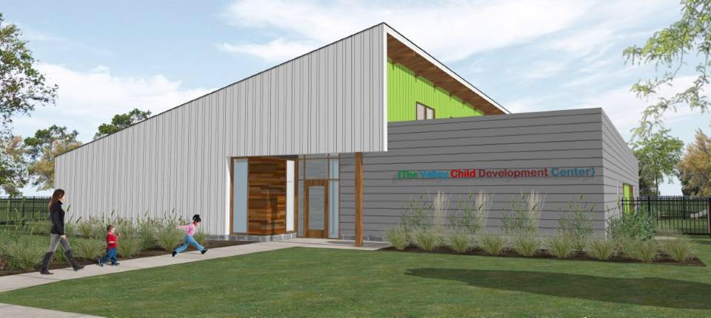 facebook.com/TheValleyChildDevelopmentCenter/

SOCIAL MEDIA
#weareRC #visitredcloud #redcloudproud #rcoh #nwcc

Chamber of Commerce: facebook.com/RedCloudChamber/
Street Car Days: facebook.com/streetcardays/
Recreation & Health: facebook.com/Red-Cloud-Recreation-Health-339872163018442/
Red Cloud Opera House: facebook.com/RedCloudOperaHouse/
Red Cloud Schools: facebook.com/RedCloudCommunitySchools/
Red Cloud Booster Club: facebook.com/RedCloudBoosterClub/
Community Foundation: facebook.com/RedCloudCommunityFoundationFund/
Willa Cather Foundation: facebook.com/WillaCatherFoundation/
twitter.com/willacatherfdn
Red Cloud Jobs: twitter.com/redcloudjobs
Visit Red Cloud: facebook.com/visitredcloudnebraska/
instagram.com/visitredcloud/
twitter.com/redcloudproud

