November 21, 2022

Dear <Salutation>,

The Red Cloud Community Fund (RCCF) believes that “good enough” is not good enough. We believe Red Cloud deserves the best, whether that be high quality childcare, great places to shop and eat, exceptional places to stay the night, or fun things to see and do. We believe that visitors to the community should have an exceptional experience and think of Red Cloud as a destination. We believe that everyone in Red Cloud deserves a high quality of life. That’s why we’re committed to investing in the future of our hometown. Great progress has been made in the community in recent years but we need your help now more than ever if we’re going to be able to sustain momentum.

That’s why this year we are asking for donations to our Heritage Tourism account. The bulk of the funding for Heritage Tourism comes from RCCF and that funding is running low. As the enclosed insert illustrates, Heritage Tourism = Economic Development for Red Cloud. Without Heritage Tourism, it’s hard to imagine where the vision to pursue the Hotel Garber project or downtown revitalization would have come from. It’s hard to imagine that local entrepreneurs and building owners would have the confidence to commit to Red Cloud. It’s hard to imagine RCCF initiating projects like the Recreation Trail, the Youth FAC group, or our successful September Month of Giving campaign that has supported various community causes. RCCF needs Heritage Tourism to flourish for the community to flourish, but we absolutely cannot help the community continue to progress without your support.

We believe that if we build a place people want to visit, people will want to live here. If people want to live here, they will want to work here. If people want to work here, businesses will want to be here. If businesses want to be here, then people will have to visit. Heritage Tourism is critical to the success of that economic development life cycle.

As always, donors are also free and encouraged to designate a gift to an account that they feel passionate about. Whatever you decide, your gift will help us make big things happen in our small town.

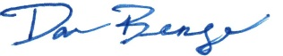
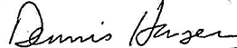
Sincerely,
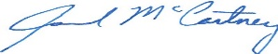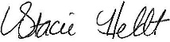
Jarrod McCartney Danny Benge Dennis Hansen Stacie Heldt
President Vice President Treasurer Secretary

